The Nevada Department of Education (NDE), Office of Student and School Supports (OSSS), aims to deepen its partnerships with Local Education Agencies (LEAs) to more effectively support the implementation of our state’s key reforms that will lead to improved outcomes for all students. More specifically, the OSSS School Improvement team strives to support LEAs in determining the quality of implementation of CSI/TSI/ATSI School Performance Plans (SPPs) in their districts. This requires not only adhering to areas of compliance, but also being deliberate in ways we streamline our collaboration efforts. Quarterly progress checks is one way to help ensure CSI/TSI/ATSI schools are making progress toward increasing student achievement and improving the quality of instruction for all students.

**Progress Update #1**

**Due Wednesday, September 30, 2020** (Flexibility for Elko, Humboldt, and White Pine due to late reopening start dates)

Submit/Post to School Website

1. Upload the PowerPoint presentation from the Stakeholder/Title I Meeting to your school’s website. The following must be captured in your presentation:

* + - Share available data from the NSPF for the prior school year (2019-2020). For those measures with no data, due to the impact of COVID-19, please indicate “NA”;
    - Share any other relevant data (i.e., results from formative testing data, needs assessment results, perception survey data, etc.);
    - Discuss your CSI/TSI/ATSI designation and what it means for your school;
    - Share your SPP goals and planned action steps for the current school year (2020-2021) in the areas of:
      1. Professional Development
      2. Family Engagement
      3. Curriculum/Instruction/Assessment

Review template for Progress Update #2 in order to plan ahead and start working on identifying targets.

**Progress Update #2**

**Due Thursday, October 29, 2020**

Submit/Post to School Website

School Performance Plan Implementation: Using data from your fall interim assessment(s) please provide a short narrative to capture your progress in the implementation of your School Performance Plan thus far.

**Professional Development**

|  |  |  |
| --- | --- | --- |
| **Progress**   * Election Day Professional Development to include PD opportunities for staff for SPED, Interventions, School City Assessments and more. The PD menu options were developed for staff from a staff and teacher survey to differentiate for teachers. * PD to be offered on how to use MAP scores/data to drive instruction for students according the readiness level indicated by MAPs. * Teachers meeting weekly for PLCs and to discuss student progress on common assessments. * SLO PD to occur on November 3. | **Barriers**   * Given the parameters that are in place during in person instruction due to COVID-19, traditional best practices in instruction have had to be sacrificed for student and staff safety (spacing, mask wearing, frequency of handwashing and sanitizing taking away instructional time, limited ability to have small group interventions early on, limited ability to have students work together in groups to further learning and discussion, etc.) * Because of COVID-19, the school master schedule has had to be altered and we are not able to offer weekly teacher PLC time during the school days. Therefore, the teacher PLC time has been moved to early release Wednesday time, cutting into professional development time. | **Next Steps**   * Plan staff On-site Novice Teacher Seminar: we have 10 staff members in classrooms that are either 1st year teachers, 2nd year teachers, or long-term subs/interventionists. These staff will attend monthly trainings of a variety of topics to support them instructionally and professionally. * Continue to offer and provide trainings and opportunities for teachers in the areas of Benchmark, AimsWeb, Technology in the Classroom and Intervention Programs before/after school * Use Fall MAPs data to determine next steps for individual and groups of students in the areas of reading and Math * Admin to meet with PLC coach from Catapult Learning, the new district vendor for the PLC Process. |

**Family Engagement**

|  |  |  |
| --- | --- | --- |
| **Progress**   * System in place for intervening for Distance Learning students who are not attending/participation, in collaboration with the district re-engagement/truancy department. * Back to School Night has already taken place and our 1st Quarter Awards Ceremony will take place via Zoom during the week of November 9. * Counselor has help first Parent University class via Zoom. * First conference week of the year has taken place via Zoom. * Bennett funds a Safe Schools Professional that supports families in connecting them with necessary community resources. | **Barriers**   * Due to COVID-19 Restrictions, families, visitors and volunteers are not permitted inside the building. * We are unable to hold in person events for typical family engagement activities such as Family Game Night, Gingerbread Night, Back to School Night, etc. * Many of our students’ parents work multiple jobs and are unable to get time of work to attend the offered virtual events at various times of the day. | **Next Steps**   * Continue work for intervening for Distance Learning students who are not attending/participation, in collaboration with the district re-engagement/truancy department. * Continue to offer varying times for parents to participate in the events hosted via Zoom with the school |

**Curriculum, Instruction, Assessment**

|  |  |  |
| --- | --- | --- |
| **Progress**   * Small group MTSS Interventions are to begin 11/2 using LLI and Phonics 1st interventions, as well as Envision interventions for math, which are being provided by our ZOOM teacher assistants and intervention teachers * Election Day Professional Development to include PD opportunities for staff for SPED, Interventions, School City Assessments and more. The PD menu options were developed for staff from a staff and teacher survey to differentiate for teachers. * Fall MAPs testing completed. * Teachers meeting weekly for PLCs and to discuss student progress on common assessments. * Continued decreased behavior events schoolwide * SLO Development Phase to begin 11/9. * System in place for intervening for Distance Learning students who are not attending/participation, in collaboration with the district re-engagement/truancy department. * Data folders have been streamlined and vertically aligned throughout the grade levels. | **Barriers**   * Students did not attend in person school for the 4th quarter of the 19/20 SY. The instruction given was based on the district’s SEL packets. Some loss of content knowledge and academic progress was experienced by all students. Additionally, many our of our students have returned to school having experienced further trauma due to the COVID-19 shutdown. * About 100 of Bennett’s students are engaging in Distance Learning this year and attendance & participation in some sub-groups has been very low. This has contributed to students’ lost instructional time and academic growth. * Given the parameters that are in place during in person instruction due to COVID-19, traditional best practices in instruction have had to be sacrificed for student and staff safety (spacing, mask wearing, frequency of handwashing and sanitizing taking away instructional time, limited ability to have small group interventions early on, limited ability to have students work together in groups to further learning and discussion, etc.) * While all of our In Person students took Fall MAPs tests, many Distance Learning students’ parents did not opt to bring them to the building so MAPs data for DL students is missing. * Currently, teachers only have one day per week during the school day for common planning within their grade level and PLC work as the early release Wednesday schedule allows. | **Next Steps**   * Plan staff On-site Novice Teacher Seminar: we have 10 staff members in classrooms that are either 1st year teachers, 2nd year teachers, or long-term subs/interventionists. These staff will attend monthly trainings of a variety of topics to support them instructionally and professionally. * Continue to offer and provide trainings and opportunities for teachers in the areas of Benchmark, AimsWeb, Technology in the Classroom and Intervention Programs * SLO process * Continue work for intervening for Distance Learning students who are not attending/participation, in collaboration with the district re-engagement/truancy department. * Our full time LS will be supporting our staff in the development of the individualized Read by Grade 3 plans as well as home reading plans for our RBG3 tiered students based on Winter MAPs scores in January. * Kindergarten students will take MAPs screeners in order to acclimate them to the MAPs testing environment and platform as well as gather additional baseline data about their literacy skills to drive instruction. * Extended School Day will be offered again this year to targeted students to bolster literacy achievement * Introduce more grade levels to the MAP screening assessments that are available to them between testing windows to track student growth in the areas of reading and math * Start SBAC interim assessments in January. |

**Elementary and Middle Schools report interim data here:**

|  |  |  |
| --- | --- | --- |
| *Goal 1: ELA*  Percentage of students at or above the 40th percentile for MAPs testing | |  |
|  | Spring 2020 Kinder scores unavailable due to COVID-19 Shutdown | Fall 2020 1st Graders – 18% |
| *Spring 2019 Kinders – 42%* | Fall 2019 1st Graders – 37% (-5) | Fall 2020 2nd Graders – 22% (-15) |
| Fall 2018 1st Graders – 50% | Fall 2019 2nd Graders – 33% (-17) | Fall 2020 3rd Graders – 43% (+10) |
| Fall 2018 2nd Graders – 25% | Fall 2019 3rd Graders – 35% (+10) | Fall 2020 4th Graders – 26% (-9) |
| Fall 2018 3rd Graders – 21% | Fall 2019 4th Graders – 33% (+12) | Fall 2020 5th Graders – 26% (-7) |
| Fall 2018 4th Graders – 52% | Fall 2019 5th Graders – 50% (-2) | NA |

1. Based on this data, list the adjustments (if any) you will be making to your action plan?

*This data indicates that, while this year’s 3rd grade students have a higher percentage of students falling above the 40th percentile in MAPs Reading, the remainder of our grade level cohorts lost students in the groups achieving at or above the 40th percentile. Some of this decline can be attributed to the fact that schools were closed for the entire 4th quarter of the school year where grade level standards-based curriculum culminates, and learning from the school is solidified. On average, only 27% of our school population is achieving at or above the 40th percentile in MAPs Reading. Teachers will be offered PD in looking at data and determining appropriate next steps for instruction according to assessment data while bolstering the PLC process.*

1. What targets will you set for the Winter benchmark based on this initial data?

MAP Growth READING - Grow the percentage of students achieving at or above the 40th percentile by 2%.

20% of 1st graders score in the 40th percentile or above by Winter 2020 MAPs Reading Assessments

24% of 2nd graders score in the 40th percentile or above by Winter 2020 MAPs Reading Assessments

45% of 3rd graders score in the 40th percentile or above by Winter 2020 MAPs Reading Assessments

28% of 4th graders score in the 40th percentile or above by Winter 2020 MAPs Reading Assessments

28% of 5th graders score in the 40th percentile or above by Winter 2020 MAPs Reading Assessments

**Elementary and Middle Schools report interim data here:**

|  |  |  |
| --- | --- | --- |
| *Goal 2: Math*  Percentage of students at or above the 40th percentile for MAPs testing | |  |
|  | Kinders do not take Math MAPs | Fall 2020 1st Graders – 29% |
| Fall 2018 Kinders - NA | Fall 2019 1st Graders – 49% | Fall 2020 2nd Graders – 28% (-21) |
| Fall 2018 1st Graders – 32% | Fall 2019 2nd Graders –33% (+1) | Fall 2020 3rd Graders – 29% (-4) |
| Fall 2018 2nd Graders – 35% | Fall 2019 3rd Graders – 35% (+0) | Fall 2020 4th Graders – 26% (-9) |
| Fall 2018 3rd Graders – 30% | Fall 2019 4th Graders – 28% (-2) | Fall 2020 5th Graders – 26% (-2) |
| Fall 2018 4th Graders – 54% | Fall 2019 5th Graders – 42% (-12) | NA |

1. Based on this data, list the adjustments (if any) you will be making to your action plan?

*This data indicates that all of our grade level cohorts lost students in the groups achieving at or above the 40th percentile. Some of this decline can be attributed to the fact that schools were closed for the entire 4th quarter of the school year where grade level standards-based curriculum culminates, and learning from the school is solidified. On average, only 27.6% of our school population is achieving at or above the 40th percentile in MAPs Math. Teachers will be offered PD in looking at data and determining appropriate next steps for instruction according to assessment data while bolstering the PLC process.*

1. What targets will you set for the Winter benchmark based on this initial data?

MAP Growth MAP - Grow the percentage of students achieving at or above the 40th percentile by 2%.

31% of 1st graders score in the 40th percentile or above by Winter 2020 MAPs Math Assessments

30% of 2nd graders score in the 40th percentile or above by Winter 2020 MAPs Math Assessments

31% of 3rd graders score in the 40th percentile or above by Winter 2020 MAPs Math Assessments

28% of 4th graders score in the 40th percentile or above by Winter 2020 MAPs Math Assessments

28% of 5th graders score in the 40th percentile or above by Winter 2020 MAPs Math Assessments

**Progress Update #3**

**Due Friday, February 26, 2021**

Submit/Post to School Website

School Performance Plan Implementation: Using data from your winter interim assessment(s) please provide a short narrative to capture your progress in the implementation of your School Performance Plan thus far.

**Professional Development**

|  |  |  |
| --- | --- | --- |
| **Progress**   * Election Day Professional Development incldued PD opportunities for staff for SPED, Interventions, School City Assessments and more. The PD menu options were developed for staff from a staff and teacher survey to differentiate for teachers. * PD is being offered on MAPs progress update following Winter MAPs, how to use MAP scores/data to drive instruction for students according the readiness level indicated by MAPs and to set SMART goals for grade levels for MAPs growth * Teachers meeting weekly for PLCs and to discuss student progress on common assessments. * SLO PD to occurred on November 3. * Admin team has been working with Catapult Learning coach who has attended several PDs and PLCs and provided feedback * Grade level teams have weekly PLC time to discuss student data and to determine next instructional steps for grade level * Novie Onsite Teacher Monthly Seminars have begun with 10 new staff members in the building. These staff attend monthly trainings of a variety of topics to support them instructionally and professionally. | **Barriers**   * Given the parameters that are in place during in person instruction due to COVID-19, traditional best practices in instruction have had to be sacrificed for student and staff safety (spacing, mask wearing, frequency of handwashing and sanitizing taking away instructional time, limited ability to have small group interventions early on, limited ability to have students work together in groups to further learning and discussion, etc.) * These restrictions also prevent our staff from meeting together in person for Professional Development and these meetings are now held on Zoom. * Because of COVID-19, the school master schedule has had to be altered and we are not able to offer the daily teacher PLC time during the school days that we had originally planned for this school year. Therefore, the teacher PLC time has been moved to early release Wednesday time, cutting into professional development time. | **Next Steps**   * Continue to offer and provide trainings and opportunities for teachers in the areas of Benchmark, AimsWeb, Technology in the Classroom and Intervention Programs before/after school * Use Winter MAPs data to determine next steps for individual and groups of students in the areas of reading and Math * Continue to use feedback from Catapult Learning coach on PD and PLC practices. |

**Family Engagement**

|  |  |  |
| --- | --- | --- |
| **Progress**   * Admin team meets weekly with a system in place for intervening for Distance Learning students who are not attending/participation, in collaboration with the district re-engagement/truancy department. * Back to School Night has already taken place as well as our 1st & 2nd Quarter Awards Ceremonies via Zoom. * Counselor has held the first two Parent University classes via Zoom. * First conference week of the year has taken place via Zoom. * A second conference week was also selected for our school to share updates in student progress with families and has been completed. * Bennett funds a School Social Worker that supports families in connecting them with necessary community resources. | **Barriers**   * Due to COVID-19 Restrictions, families, visitors and volunteers are not permitted inside the building. * We are unable to hold in person events for typical family engagement activities such as Family Game Night, Gingerbread Night, Back to School Night, etc. * Many of our students’ parents work multiple jobs and are unable to get time of work to attend the offered virtual events at various times of the day. * Parent University classes have not been as well attended as they are being held via Zoom and many of our families lack the technology access required to attend. * In referring families to the district truancy department for severe chronic absenteeism, it has been reported back to us by the department that they are currently at capacity for new cases. | **Next Steps**   * Continue work for intervening for Distance Learning students who are not attending/participation, in collaboration with the district re-engagement/truancy department. * Continue to offer varying times for parents to participate in the events hosted via Zoom with the school |

**Curriculum, Instruction, Assessment**

|  |  |  |
| --- | --- | --- |
| **Progress**   * Small group MTSS Interventions have begun (as of 11/2) for Tier 3 students using LLI and Phonics 1st interventions, as well as Envision interventions for math, which are being provided by our ZOOM teacher assistants and intervention teachers * Election Day Professional Development included PD opportunities for staff for SPED, Interventions, School City Assessments and more. The PD menu options were developed for staff from a staff and teacher survey to differentiate for teachers. * Fall & Winter MAPs testing completed. * Teachers meeting weekly for PLCs and to discuss student progress on common assessments during Wednesday early release time. * SLO Development Phase to begin 11/9. * System in place for intervening for Distance Learning students who are not attending/participation, in collaboration with the district re-engagement/truancy department. * Data folders have been streamlined and vertically aligned throughout the grade levels. * A schoolwide attendance competition was held from January 11-February 12 to promote improved attendance. Attendance data indicate that schoolwide there has been an 8% decrease in absences during the time of the attendance competition and this trend continues. * A cohort of students are participating in extended school day receiving extra reading support before and after school several days per week. This is funded through our Zoom budget. * Our full time LS has been supporting our staff in the development of the individualized Read by Grade 3 plans as well as home reading plans for our RBG3 tiered students based on Winter MAPs scores in January. | **Barriers**   * Students did not attend in person school for the 4th quarter of the 19/20 SY. The instruction given was based on the district’s SEL packets. Some loss of content knowledge and academic progress was experienced by all students. Additionally, many of our students have returned to school having experienced further trauma due to the COVID-19 shutdown. * About 120 of Bennett’s students are engaging in Distance Learning this year and attendance & participation in some sub-groups has been very low. This has contributed to students’ lost instructional time and academic growth. * Furthermore, attendance for our in person students has also been staggeringly less this year than in years past. * Given the parameters that are in place during in person instruction due to COVID-19, traditional best practices in instruction have had to be sacrificed for student and staff safety (spacing, mask wearing, frequency of handwashing and sanitizing taking away instructional time, limited ability to have small group interventions early on, limited ability to have students work together in groups to further learning and discussion, etc.) * While all of our In Person students took Fall MAPs tests, many Distance Learning students’ parents did not opt to bring them to the building so MAPs data for DL students is missing. * Because 4th and 5th graders were not required to take the MAPs test, per Read by Grade 3, many 4th and 5th grade distance learning families opted out of having their students tested in the Winter session. * Currently, teachers only have one day per week during the school day for common planning within their grade level and PLC work as the early release Wednesday schedule allows. * In the second semester, an increase in student behavior events has occurred, however, these behaviors are occurring on the playground and are minimally impacting instructional time. * In referring families to the district truancy department for severe chronic absenteeism, it has been reported back to us by the department that they are currently at capacity for new cases. | **Next Steps**   * Continue On-site Novice Teacher Seminar: we have 10 staff members in classrooms that are either 1st year teachers, 2nd year teachers, or long-term subs/interventionists. These staff will continue to attend monthly trainings of a variety of topics to support them instructionally and professionally. * Continue to offer and provide trainings and opportunities for teachers in the areas of Benchmark, AimsWeb, Technology in the Classroom and Intervention Programs * SLO process * Continue work for intervening for Distance Learning students who are not attending/participation, in collaboration with the district re-engagement/truancy department. * Kindergarten students will take MAPs screeners in order to acclimate them to the MAPs testing environment and platform as well as gather additional baseline data about their literacy skills to drive instruction. * Introduce more grade levels to the MAP screening assessments that are available to them between testing windows to track student growth in the areas of reading and math * Start SBAC interim assessments in January. |

**Elementary and Middle Schools report interim data here:**

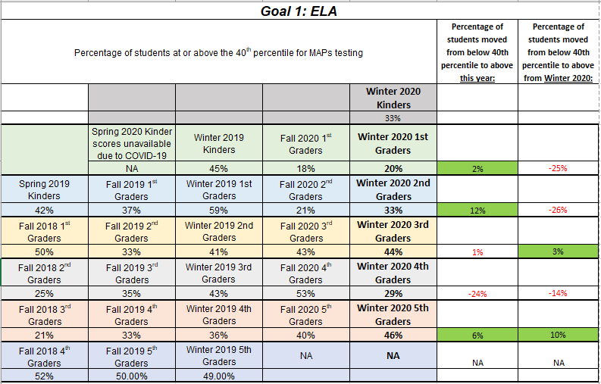

1. Did you meet the targets established after the Fall interim assessment?

Goals from Fall TSI Update Tool:

MAP Growth READING - Grow the percentage of students achieving at or above the 40th percentile by 2%.

20% of 1st graders score in the 40th percentile or above by Winter 2021 MAPs Reading Assessments

24% of 2nd graders score in the 40th percentile or above by Winter 2021 MAPs Reading Assessments

45% of 3rd graders score in the 40th percentile or above by Winter 2021 MAPs Reading Assessments

28% of 4th graders score in the 40th percentile or above by Winter 2021 MAPs Reading Assessments

28% of 5th graders score in the 40th percentile or above by Winter 2021 MAPs Reading Assessments

| **X** Yes | □ No |
| --- | --- |
| What if any adjustments will you make to your 2021-2022 School Performance Plan?   * While all of our grade levels, with the exception of 3rd grade by 1 percentage point, met the goals that were set forth in the fall for Reading MAPs testing, their growth will not adequately recover what is needed to grow 2% from Winter of 2019 to this year. * We will be bolstering our PDs around data analyses and be sharing our Winter MAP data (and the historical data for each grade level’s cohorts) with our teachers. Teachers have identified their grade level student who are falling in the below average range and have begun to set SMART goals for this group. Next, teachers will be using MAPs Student Reports to identify which strands each of their below average students are ready to begin developing for both Math and ELA. Teachers will then identify their action steps for their students based on these reports. * An updated walkthrough tool has been developed and will be rolled out beginning March 1 which focuses on the first semester focus of planning and preparation but also with an added emphasis on instruction. | What adjustments will you make to your 2021-2022 School Performance Plan? |

2. What targets will you set for the spring benchmark based on this initial data?

22% of Kindergartners score in the 40th percentile of above by Spring 2021 MAPs Reading Assessments

47% of 1st graders score in the 40th percentile or above by Spring 2021 MAPs Reading Assessments

61% of 2nd graders score in the 40th percentile or above by Spring 2021 MAPs Reading Assessments

43% of 3rd graders score in the 40th percentile or above by Spring 2021 MAPs Reading Assessments

45% of 4th graders score in the 40th percentile or above by Spring 2021 MAPs Reading Assessments

38% of 5th graders score in the 40th percentile or above by Spring 2021 MAPs Reading Assessments

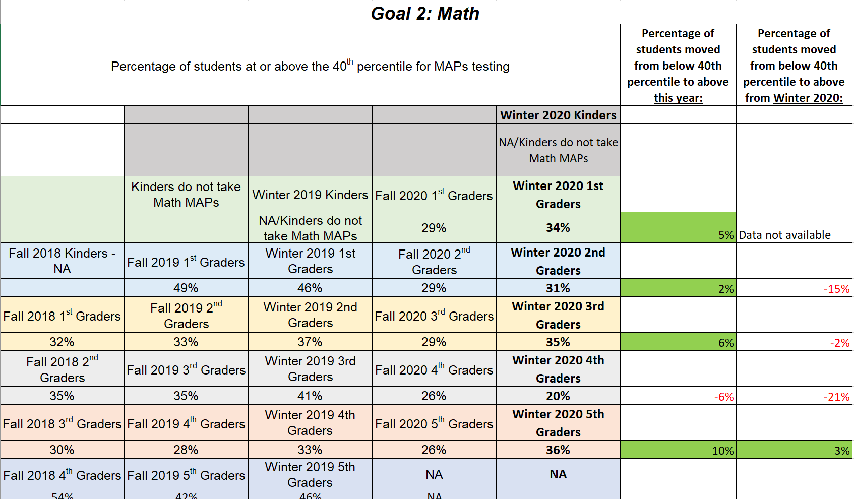

1. Did you meet the targets established after the Fall interim assessment?

Goals from Fall TSI Update Tool:

MAP Growth Math - Grow the percentage of students achieving at or above the 40th percentile by 2%.

31% of 1st graders score in the 40th percentile or above by Winter 2020 MAPs Math Assessments

30% of 2nd graders score in the 40th percentile or above by Winter 2020 MAPs Math Assessments

31% of 3rd graders score in the 40th percentile or above by Winter 2020 MAPs Math Assessments

28% of 4th graders score in the 40th percentile or above by Winter 2020 MAPs Math Assessments

28% of 5th graders score in the 40th percentile or above by Winter 2020 MAPs Math Assessments

| **X** Yes | □ No |
| --- | --- |
| What if any adjustments will you make to your 2021-2022 School Performance Plan?   * While most of all of our grade levels, with the exception of 4th grade by 8%, met the goals that were set forth in the fall for Math MAPs testing, their growth will not adequately recover what is needed to grow 2% from Winter of 2019 to this year. * We will be bolstering our PDs around data analyses and be sharing our Winter MAP data (and the historical data for each grade level’s cohorts) with our teachers. Teachers have identified their grade level student who are falling in the below average range and have begun to set SMART goals for this group. Next, teachers will be using MAPs Student Reports to identify which strands each of their below average students are ready to begin developing for both Math and ELA. Teachers will then identify their action steps for their students based on these reports. * An updated walkthrough tool has been developed and will be rolled out beginning March 1 which focuses on the first semester focus of planning and preparation but also with an added emphasis on instruction. | What adjustments will you make to your 2021-2022 School Performance Plan? |

2. What targets will you set for the spring benchmark based on this initial data?

36% of 1st graders score in the 40th percentile or above by Spring 2021 MAPs Math Assessments

48% of 2nd graders score in the 40th percentile or above by Spring 2021 MAPs Reading Assessments

39% of 3rd graders score in the 40th percentile or above by Spring 2021 MAPs Reading Assessments

43% of 4th graders score in the 40th percentile or above by Spring 2021 MAPs Reading Assessments

35% of 5th graders score in the 40th percentile or above by Spring 2021 MAPs Reading Assessments

**Progress Update #4**

**Due Wednesday, May 26, 2021**

Submit/Post to School Website

School Performance Plan Implementation: Using data from your spring interim assessment(s) please provide a short narrative to capture your progress in the implementation of your School Performance Plan thus far.

**Professional Development**

|  |  |  |
| --- | --- | --- |
| **Progress**   * Election Day Professional Development included PD opportunities for staff for SPED, Interventions, School City Assessments and more. The PD menu options were developed for staff from a staff and teacher survey to differentiate for teachers. * PD is was offered on MAPs progress update following Winter MAPs, how to use MAP scores/data to drive instruction for students according the readiness level indicated by MAPs and to set SMART goals for grade levels for MAPs growth * Admin and Catapult Learning Consultants supported struggling grade levels during their PLCs to develop instruction according to the data * Teachers meeting weekly for PLCs and to discuss student progress on common assessments. * SLO PD to occurred on November 3. * Admin team has been working with Catapult Learning coach who has attended several PDs and PLCs and provided feedback * Grade level teams have weekly PLC time to discuss student data and to determine next instructional steps for grade level * Novice Onsite Teacher Monthly Seminars have begun with 10 new staff members in the building. These staff attend monthly trainings of a variety of topics to support them instructionally and professionally. * Next year’s master schedule has been developed in such a way that, barring any limitations due to COVID and/or staffing, should allow grade level teachers to meet together for 1 hour per day, during each school day. | **Barriers**   * Given the parameters that are in place during in person instruction due to COVID-19, traditional best practices in instruction have had to be sacrificed for student and staff safety (spacing, mask wearing, frequency of handwashing and sanitizing taking away instructional time, limited ability to have small group interventions early on, limited ability to have students work together in groups to further learning and discussion, etc.) * These restrictions also prevent our staff from meeting together in person for Professional Development and these meetings are now held on Zoom. * Because of COVID-19, the school master schedule has had to be altered and we are not able to offer the daily teacher PLC time during the school days that we had originally planned for this school year. Therefore, the teacher PLC time has been moved to early release Wednesday time, cutting into professional development time. | **Next Steps**   * Continue to offer and provide trainings and opportunities for teachers in the areas of Benchmark, AimsWeb, Technology in the Classroom and Intervention Programs before/after school * Use Winter MAPs data to determine next steps for individual and groups of students in the areas of reading and Math * Continue to use feedback from Catapult Learning coach on PD and PLC practices. * Next year’s master schedule has been developed in such a way that, barring any limitations due to COVID and/or staffing, should allow grade level teachers to meet together for 1 hour per day, during each school day. * The PLC plan for the upcoming school year will begin with the development of SMART goals based on this year’s MAPs scores. Then, teachers will set smaller SMART goals during the interval of instruction between MAPs tests to assess student growth towards their targeted skills. |

**Family Engagement**

|  |  |  |
| --- | --- | --- |
| **Progress**   * Admin team (Principal, AP, School Social Worker, & Counselor) meets weekly with a system in place for intervening for all students who are not attending in person or on distance learning in collaboration with the district re-engagement/truancy department. * Back to School Night took place as well as our 1st, 2nd & 3rd Quarter Awards Ceremonies via Zoom. * End of year celebrations for Kinder and 5th grade students with their parents are being planned. * Counselor held the first two Parent University classes via Zoom. * Two conference weeks took place via Zoom. * Bennett funds a School Social Worker that supports families in connecting them with necessary community resources. | **Barriers**   * Due to COVID-19 Restrictions, families, visitors and volunteers are not permitted inside the building. * We are unable to hold in person events for typical family engagement activities such as Family Game Night, Gingerbread Night, Back to School Night, etc. * Many of our students’ parents work multiple jobs and are unable to get time of work to attend the offered virtual events at various times of the day. * Parent University classes have not been as well attended as they are being held via Zoom and many of our families lack the technology access required to attend. * In referring families to the district truancy department for severe chronic absenteeism, it has been reported back to us by the department that they are currently at capacity for new cases. | **Next Steps**   * Continue work for intervening for all students who are not attending/participation, in collaboration with the district re-engagement/truancy department. Next year, these weekly meetings and efforts will include additional support for behavior students. * Next year we will continue to offer varying times for parents to participate in the events hosted via Zoom and in person with the school |

**Curriculum, Instruction, Assessment**

|  |  |  |
| --- | --- | --- |
| **Progress**   * Small group MTSS Interventions were held (as of 11/2) for Tier 3 students using LLI and Phonics 1st interventions, as well as Envision interventions for math, which are being provided by our ZOOM teacher assistants and intervention teachers * Election Day Professional Development included PD opportunities for staff for SPED, Interventions, School City Assessments and more. The PD menu options were developed for staff from a staff and teacher survey to differentiate for teachers. * Fall, Winter & Spring MAPs testing completed. * SBAC testing was completed for the first time in 2 years. * Teachers meeting weekly for PLCs and to discuss student progress on common assessments during Wednesday early release time. * SLOs were completed. * Weekly attendance meetings and system was implemented to intervene for In Person and Distance Learning students who were not attending/participating, in collaboration with the district re-engagement/truancy department. * Data folders were streamlined and vertically aligned throughout the grade levels. * A schoolwide attendance competition was held from January 11-February 12 to promote improved attendance. Attendance data indicate that schoolwide there has been an **17% decrease** in absences during the school year. * A cohort of students participated in extended school day receiving extra reading support before and after school several days per week. This is funded through our Zoom budget. * Our full time LS has been supporting our staff in the development of the individualized Read by Grade 3 plans as well as home reading plans for our RBG3 tiered students based on Winter MAPs scores in January. | **Barriers**   * Our Zoom funding for intervention teachers (x3) has been eliminated about the 21-22 school year. * Students did not attend in person school for the 4th quarter of the 19/20 SY. The instruction given was based on the district’s SEL packets. Some loss of content knowledge and academic progress was experienced by all students. Additionally, many of our students have returned to school having experienced further trauma due to the COVID-19 shutdown. * About 120 of Bennett’s students are engaging in Distance Learning this year and attendance & participation in some sub-groups has been very low. This has contributed to students’ lost instructional time and academic growth. * Furthermore, attendance for our in person students has also been staggeringly less this year than in years’ past. * Given the parameters that are in place during in person instruction due to COVID-19, traditional best practices in instruction have had to be sacrificed for student and staff safety (spacing, mask wearing, frequency of handwashing and sanitizing taking away instructional time, limited ability to have small group interventions early on, limited ability to have students work together in groups to further learning and discussion, etc.) * While all of our In Person students took Fall MAPs tests, many Distance Learning students’ parents did not opt to bring them to the building so MAPs data for DL students is missing. * Because 4th and 5th graders were not required to take the MAPs test, per Read by Grade 3, many 4th and 5th grade distance learning families opted out of having their students tested in the Winter session. * Currently, teachers only have one day per week during the school day for common planning within their grade level and PLC work as the early release Wednesday schedule allows. * In the second semester, an increase in student behavior events has occurred, however, these behaviors are occurring on the playground and are minimally impacting instructional time. * In referring families to the district truancy department for severe chronic absenteeism, it has been reported back to us by the department that they are currently at capacity for new cases. | **Next Steps**   * Continue to offer and provide trainings and opportunities for teachers in the areas of Benchmark, AimsWeb, Technology in the Classroom and Intervention Programs * Continue work for intervening for all students who are not attending/participation, in collaboration with the district re-engagement/truancy department. * Next year, weekly attendance meetings with the administrative team will include supports for students with behavioral concerns. * Next year, the MTSS process will be streamlined in order for teachers to report data on students not making sufficient progress towards goals given current interventions. * Kindergarten students will take MAPs screeners in order to acclimate them to the MAPs testing environment and platform as well as gather additional baseline data about their literacy skills to drive instruction. * Introduce more grade levels to the MAP screening assessments that are available to them between testing windows to track student growth in the areas of reading and math * Start SBAC interim assessments in January. |

**Elementary and Middle Schools report interim data here:**

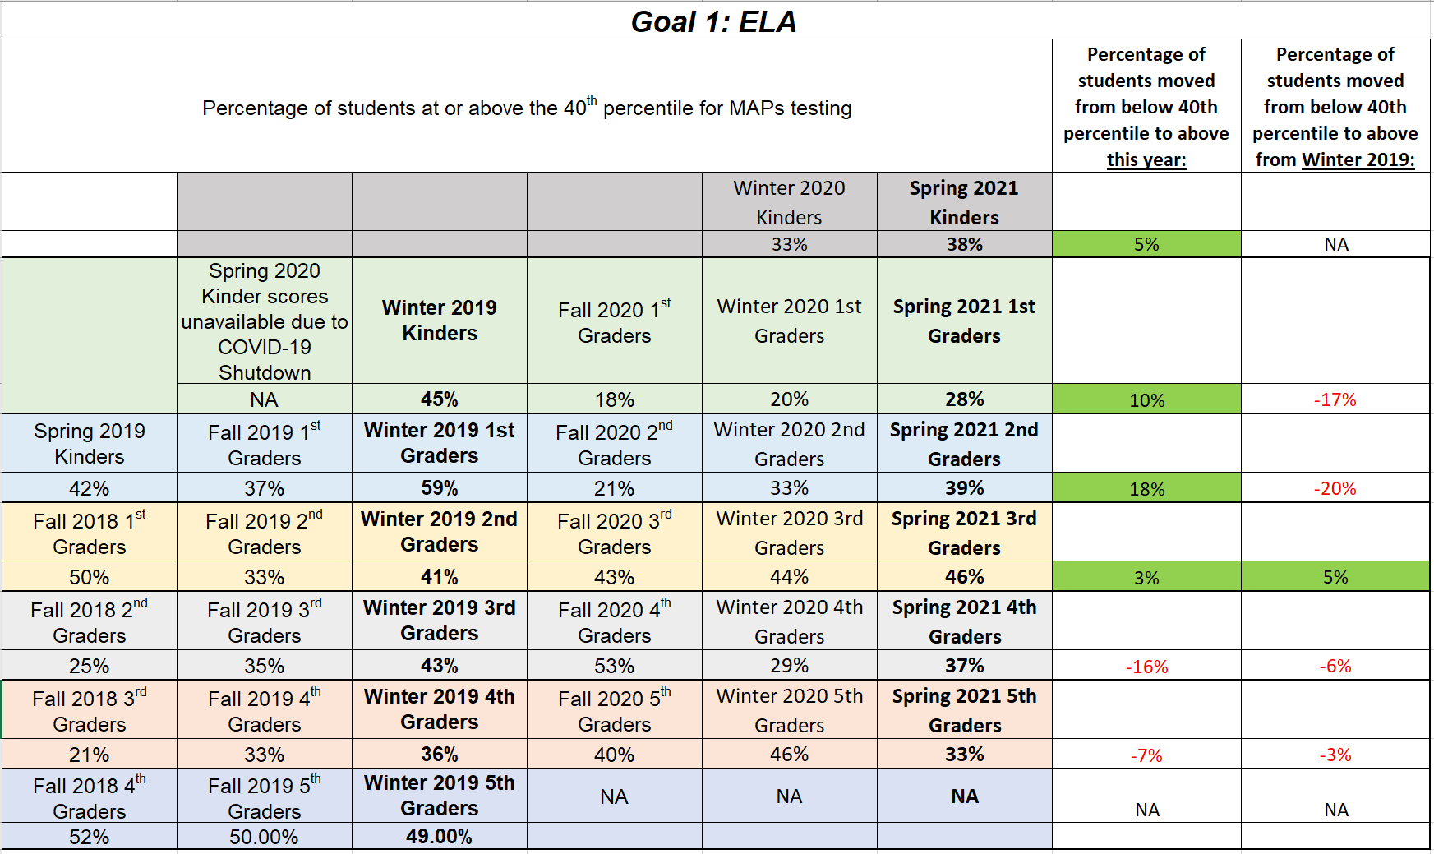

**Elementary and Middle Schools report interim data here:**

1. Did you meet the targets established after the Winter interim assessment?

| □ Yes | □ No |
| --- | --- |
| What if any adjustments will you make to your 2021-2022 School Performance Plan? | What adjustments will you make to your 2021-2022 School Performance Plan? |

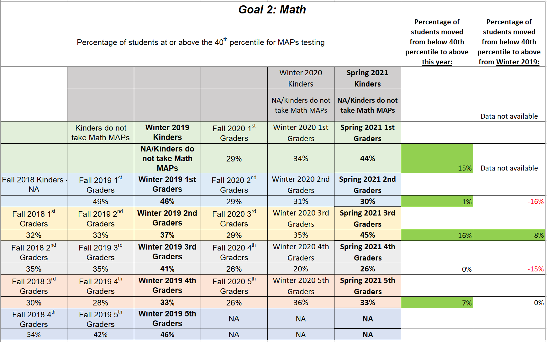

1. Did you meet the targets established after the Winter interim assessment?

| **X** Yes | □ No |
| --- | --- |
| What if any adjustments will you make to your 2021-2022 School Performance Plan? | What adjustments will you make to your 2021-2022 School Performance Plan? |

* Bennett will start the school year with teachers reviewing their grade level students’ MAPs scores from the 2021 Spring assessments. In order to recover lost instruction and grow the cohort of students to show 2% growth from their Winter 2019 MAPs (prior to COVID), we will set growth targets accordingly to show 2% growth from Winter 2019 to Spring 2022.
  + Ex:
    - 41% of 3rd graders were at or above in the Math MAPs in the Winter of 2019.
    - In the Spring of 2021, 26% of this group of students was at or above average in Math MAPs.
    - In the Fall of 2021, 4th Grade teachers will set SMART goals for this grade level/cohort of students that 35% of their students will score in the at or above average range during their Winter 2021 MAPS Math assessments (=+9% growth).
    - Then, they will set SMART goals that 43% (+2% growth from Winter 2019) of their group of students will score in the at or above average range in Math MAPs during the Spring of 2022 (+9% growth).
* We will also include 2021 SBAC assessment scores as a new starting point for measuring student growth in Reading and Math.